Maria Sibylla Merian (1647 – 1717)

The daughter of an artist and etcher, Maria Sibylla Merian studied art under both her father and stepfather. As tradition dictated, Maria remained at home to study, often finding subjects around her for her paintings, including plants and insects, while her half-brothers traveled to many major European cities to study. She married the top student of her stepfather’s, Johann Graff, and led a relatively quiet life in his hometown of Nuremberg. She continued to paint, taught art to some female students, and collected caterpillars to observe their metamorphoses to butterflies. This began her study of the caterpillars and their host plants. Maria began to tell their life story in her paintings.
Her paintings crossed barriers as scientific boundaries: Maria included both plants and animals in her pictures. She organized her pictures aesthetically into a book, the Raupen, to introduce people to “more than a hundred transformations.” (Davis, 154). She continued to collect specimens and raise butterflies at her home. Her two daughters studied under the tutelage of their mother. Eventually, she left her husband and moved to Amsterdam. Upon seeing a plate of a New World butterfly, Maria took a journey to Surinam. She was 52 years old, accompanied by her daughter, on this difficult trip. She paid her own way by selling her prints and specimens.
Again, Maria collected, raised, studied and painted caterpillars and their host plants. For two years she worked to learn as much as she could about the flora and fauna of Surinam, preparing specimens for return to Amsterdam. She was forced to return to Amsterdam in 1701 after contracting malaria. She then collected her work into a major work, Metamorphosis insectorum Surinamensuim, following the life cycles of the insects and giving more evidence to the work of Francisco Redi in the dismantling of the theory of spontaneous generation.
Maria Sibylla Merian died in 1717. Her work had been recognized by researchers who have named 17 species of organisms after her, as well as for her art.
Your work in this module is to examine the difficulties of studying insects and the effort taken to raise and observe butterflies.

References:
Davis, Natalie. 1995. Women on the margins: three seventeenth-century lives. Harvard University Press: Cambridge, MA.
Meyer, Gerald. 1955. The Scientific Lady in England 1650 – 1760: An Account of Her Rise, with Emphasis on the Major Roles of the Telescope and Microscope. University of California Press: Berkeley, CA.
Schiebinger, Londa. 1989. The mind has no sex? Women in the origins of modern science. Harvard University Press: Cambridge, MA.
www.enature.com
www.monarchlab.umn.edu for adaptations of their activities
Maria Sibylla Merian (1647 – 1717)
- Daughter of a painter and etcher
- Study of art began her interest in insects
- Interest continued as she tried to find caterpillars that produced fine silk
- Became an expert at raising butterflies
- Illustrated the life cycles of butterflies
- Traveled to Surinam to study insects
- Continued to publish paintings of life
cycles until her death
Name:
Date:
Period:

Activity 1: Recognizing Things You Have Never Seen
Imagine you are in Surinam in 1700, having sold the last of your valuable paintings for your journey to the New World. You are most interested in painting the insects and plants that many in your homeland have never seen. Having seen one example of a New World butterfly in a curiosity cabinet, you decide that caterpillars and butterflies are a good place to start. You want to send back paintings as soon as possible to your friends and colleagues, so instead of collecting right away, you observe the organisms in the wild and begin your studies. On your way back to your new home, you drop your portfolio of paintings and get them all mixed together. Your job is now to try to match the caterpillar with the butterfly.

Objective: To observe the difficulties of working in a strange place with new organisms.

Materials:
Pen or Pencil
Envelope of pictures of butterflies and caterpillars

Procedure:
- Break up into groups of three.
- Take out the twenty pictures in your envelope.
- Individually, using your observational skills, try to match each caterpillar with the butterfly it becomes. Write your matches in the space below.
- Share your matches in your group. Come to an agreement of the matches for your group and write them in the appropriate space below.
- Answer the questions that follow.

- List your matches of caterpillar and butterfly in the space provided.

- List the matches of your group in the space below.

3. Was it difficult for your group to agree on the matching of caterpillar to butterfly? Why or why not?

- How could you have prevented the difficulties you faced in this activity?

- You do not have a teacher to determine if you are right or wrong. How would you determine if you are correct? Write a procedure to follow.

Name:
Date:
Period:

Activity 2: Raising a Family

Now that you have tried to pair the caterpillar to butterfly in Activity 1, you will follow Maria Merian’s example and raise some butterflies yourself. Merian was able to illustrate the life cycles because she was skilled at rearing and observation. These paintings were the only way to communicate what she saw, as in 1700, there were no cameras or video recorders.

Procedure:
- Find the jar with your name; these caterpillars will be yours for which to care.
- Be sure the milkweed is fresh every day.
- On the following data sheet, keep track of your caterpillars each day throughout its life cycle.
- In your notebook, sketch the host plant and each stage of the life cycle.
- Should your caterpillar make it to butterfly stage, free it the day after it emerges.
- Upon completion, create a piece of art that shows the plant and all stages of the life of your monarch butterfly. You may use any medium to express yourself; however, your renderings should be true to life.

Name:
Period:
Date:

Fill in the chart every day until the release of your specimens.

Date | Number of specimen | Length in mm | Weight in mg | Observations: instar or stage, signs of molting, feeding habits, etc.

Name:
Period:
Date:

Activity 3: Mortality Rates

Not all of these insects you have been raising will make it to adulthood. A very small percentage in the wild actually survives to the adult stage. While Merian was interested in representing the life cycle of the butterflies, we can learn a great deal from the mortality of our population. In this activity we are going to determine the stage at which most mortality occurs in our population and try to determine the primary cause of mortality.

Possible causes of mortality include parasites, disease, or prey. Assuming we will not have any predatory animals in the lab, we will focus on parasites and disease. In order to make a determination as to the cause of death, you will need to continue to observe the specimens for several days after death.

You should look for:

Tiny white maggots that form dark brown pupae – parasitized by a fly
Black in color and full of foul smelling liquid – infected by virus

Before you begin and using what you have learned so far, hypothesize as to which stage will have the highest mortality and why.

Hypothesis:

Procedure:

- See Activity 2 for procedures for raising butterflies.
- If one of your specimens dies, place it in a separate container in the back of the room.
- Everyone is responsible for recording her/his information on mortality everyday.
- Fill in the chart below and answer the questions that follow.

Stage | Total number observed | Number that died | %age that died | Observations and cause of death
Larva
Pupa
Adult
Questions:

- Which stage had the highest mortality? Why do you believe that particular stage was most vulnerable to disease or parasites?

- Look online for mortality rates from other areas of the country. How do the rates you found compare? If there are differences, explain why you think we did not find the same rates.

- How would you study mortality rates in the field? Write a procedure for studying mortality rates of monarch butterflies in the wild.

- Look at your artwork from the previous activity. Create an accompanying piece that reflects the specimens we have now. Include one that has been parasitized.

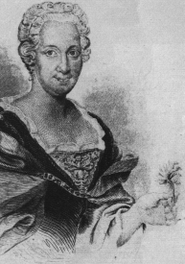
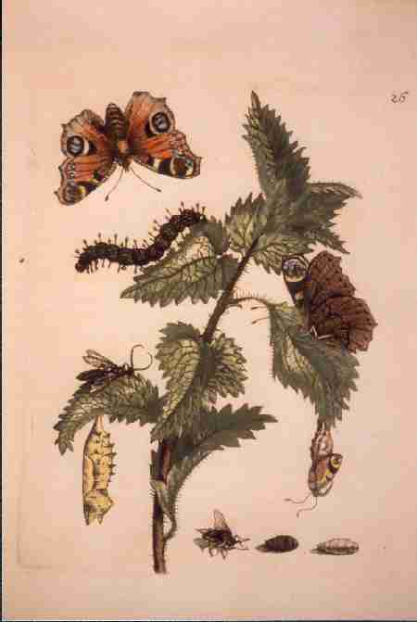
"Große Brenn-Nessel", Nr. 26 from Raupenbuch, I.Teil (1679)
http://www.gymsm.krefeld.schulen.net/ausstell/stubuch.htm#top

http://cgee.hamline.edu/see/mariasyblla/see_an_merian.html

