The LED Lasso

Can you see AC?
AC current is called “Alternating Current” because AC current changes directions as it flows through a wire. AC current travels one way down a wire and then alternates its direction and travels the opposite way down the same wire. In fact, AC current changes directions sixty times a second!

In the following experiment, you can use a special light, called a bicolor LED, to prove that AC current actually changes directions.

- Plug in the AC transformer attached to the bicolor LED (see picture below).
- Hold the bicolor LED up to your eye and see what color it is.
- Move the bicolor LED back and forth and see what color(s) you can see.
- Spin the bicolor LED around in a circle and see what color(s) you can see.
- What is different when you move the bicolor LED around?
- Why does it seem like the lights are always on when you hold the bicolor LED still, but they blink on and off when you move them?
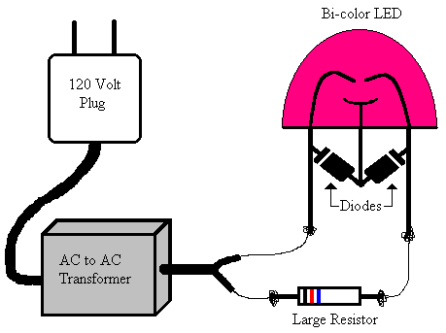
How it works:
An LED is a special kind of light that only works when electricity flows through it in a particular direction. Therefore an LED should blink on and off when attached to AC current, because AC current alternates its direction and the LED will only works when the current is traveling in the right direction. A bicolor LED is an LED with two colors, in this case green and red. Since the bicolor LED has two colors, you can set it up so it’s green when the AC current is traveling in one direction and red when the current is traveling in the opposite direction.

The human brain processes visual information at about forty times a second. If a light blinks slower than forty times a second you can tell it’s blinking, but if a light blinks faster than forty times a second your brain thinks the light is always on, even though it is actually blinking! By moving the bicolor LED back and forth, the two lights blink in different places so your brain doesn’t mix the two colors. When you stop moving the bicolor LED your brain mixes the green and red colors together and the bicolor LED looks orange. Thomas Edison used this idea to make still pictures come to life when he invented the first motion picture.

