

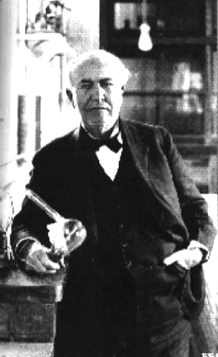
The answer is yes and no. Thomas Edison’s laboratory at Menlo Park, New Jersey was indeed responsible for creating the first practical light bulb. However, Edison had hired a group of brilliant scientists and engineers to assist him in creating his inventions that was called the Edison Pioneers.
Thomas Alva Edison
In the publicity created for many of Edison’s inventions, the public was given the impression that Edison himself was soley responsible for the inventions. In fact, members of the Edison Pioneers were instrumental in creating important elements of many of his inventions.
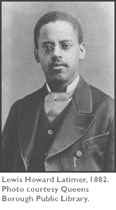
In the case of the filament in the light bulb, Lewis Latimer (the only African-American member of the Edison Pioneers) did the majority of the work in finding a filament that would not burn out too quickly.
Lewis Latimer

The final solution was a cotton thread coated with carbon which lasted longer than previous filaments made from paper or bamboo.

