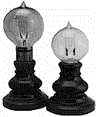


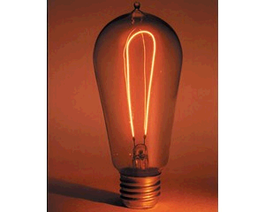
1890 Edison Light Bulb 40 Watt

Material:

Jar
Power supply
Small wire
Medium wire
Large wire
Steel wool

Copper wire

Instructions:

- Choose a filament

- Connect the filament to the alligator clips under the lid.

- Place the filament into the jar and close the lid.

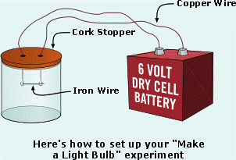
- Hook the free ends of alligator clips to the power supply. What happens?
“Filament”
Lid
Alligator Clip

Power Supply

- Which filament works best?

