Thomas Edison's Filament Experiment.

Equipment:
- Nichrome wire 10 feet of both 32 and 28 gauge wire
(Wiretronic inc. 1-888-947-3876)

- Copper wire 20 feet of wire

- Mason Jars Six jars (found in grocery stores for canning fruit)

- Tea light candles Six candles (and matches to light the candles)

- Batteries At least ten 6 volt batteries

- Wire cutters/strippers

- Scotch Tape

Set-up: (See example below)
- Punch two holes in the metal cap of a mason jar.
- Get two pieces of copper wire about 6 inches in length.
- Use a wire stripper to strip the insulation off both ends of the wires.
- String one of the copper wires halfway through a hole in the jar lid.
- Tape the wire down to the top of the lid with scotch tape.
- Repeat the last two steps with the other copper wire.
- Cut lengths of nichrome wire (about 2 inches) to test.

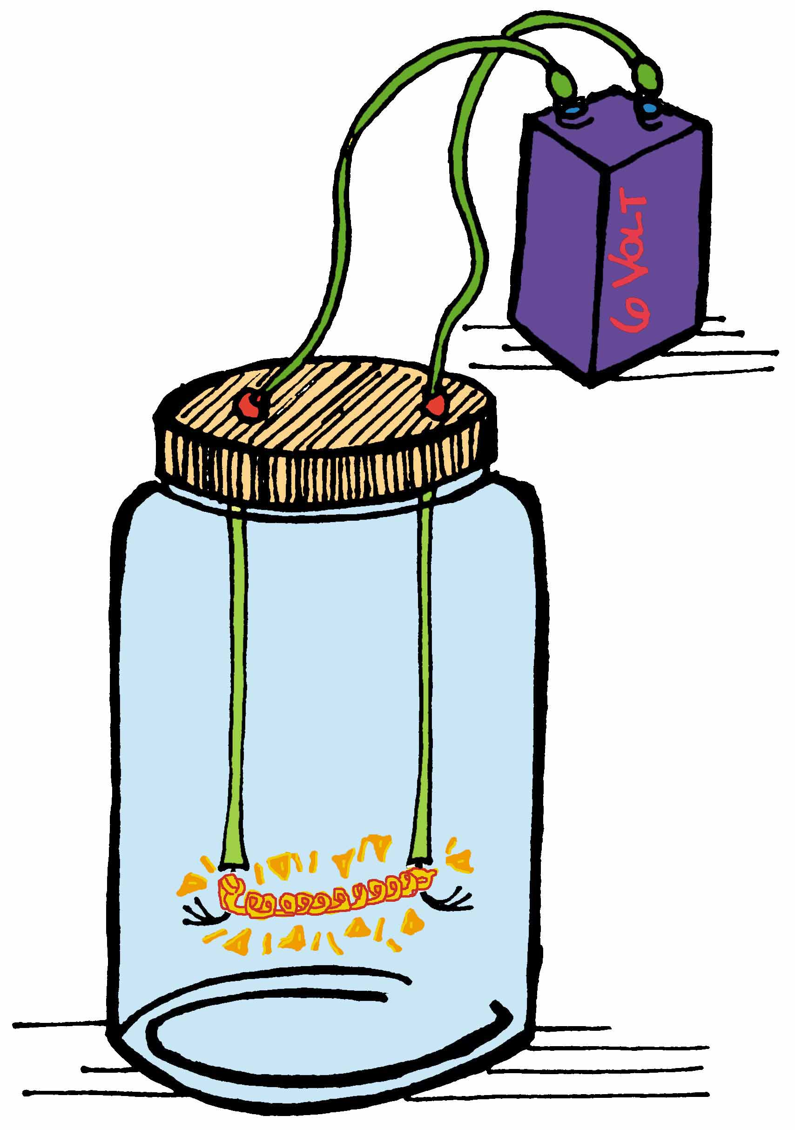
Directions:
- Unscrew the lid of the mason jar.
- Get a length of nichrome wire and attach it to the two copper wires.
- Screw the lid back on the jar.
- Attach a 6 volt battery to the wires on the outside of the jar and see if the filament will light.
- Try a different gauge of wire. Does it work better, last longer, Etc.?
- What would happen if you could get rid of the oxygen in the mason jar before lighting up the filament? How could you do this? (Hint: candle)
- Try different batteries or more batteries in series or parallel. What happens? What else could you test?

